**Experiment:-1.3**

**Write a program to implement the functions on a stack:**

* 1. PUSH
  2. POP
  3. OVERFLOW& UNDERFLOW

**Student Name:-Neha Sharma UID:-20BCS4576**

**Branch:- CSE-IOT Section/Group:- A**

**Semester:-3rd Date of Performance:-7/09/2021**

**Subject Name:- DS LAB Subject Code:-20CSP-231**

**1. Aim/Overview of the practical:- Write a program to implement the functions on a stack:**

PUSH

POP

OVERFLOW& UNDERFLOW

**2. Task to be done:-** Write a C program to implement stack data structure with push and pop operation. In this post I will explain stack implementation using array in C language.

**3. Algorithm/Flowchart:**

**For PUSH**

Step 1: **If Top=Max-1**

**Print “Overflow : Stack is full” and Exit**

**End If**

Step 2: **Top=Top+1**

Step 3: **Stack[TOP]=Element**

Step 4: **End**

**For POP**

Step 1: **If TOP=-1**

**Print “Underflow: Stack is empty” and Exit**

**End if**

Step 2: **Set Del_element=Stack[Top]**

Step 3: **Top=Top-1**

Step 4: **Del_Element**

Step 5: **End**

**4. Steps for experiment/practical:**

#include <stdio.h>

#include <stdlib.h>

#include <limits.h> // For INT_MIN

#define SIZE 100

// Create a stack with capacity of 100 elements

int stack[SIZE];

// Initially stack is empty

int top = -1;

/* Function declaration to perform push and pop on stack */

void push(int element);

int pop();

int main()

{

int choice, data;

while(1)

{

/* Menu */

printf("------------------------------------\n");

printf(" STACK IMPLEMENTATION PROGRAM \n");

printf("------------------------------------\n");

printf("1. Push\n");

printf("2. Pop\n");

printf("3. Size\n");

printf("4. Exit\n");

printf("------------------------------------\n");

printf("Enter your choice: ");

scanf("%d", &choice);

switch(choice)

{

case 1:

printf("Enter data to push into stack: ");

scanf("%d", &data);

// Push element to stack

push(data);

break;

case 2:

data = pop();

// If stack is not empty

if (data != INT_MIN)

printf("Data => %d\n", data);

break;

case 3:

printf("Stack size: %d\n", top + 1);

break;

case 4:

printf("Exiting from app.\n");

exit(0);

break;

default:

printf("Invalid choice, please try again.\n");

}

printf("\n\n");

}

return 0;

}

/**

* Functiont to push a new element in stack.

*/

void push(int element)

{

// Check stack overflow

if (top >= SIZE)

{

printf("Stack Overflow, can't add more element element to stack.\n");

return;

}

// Increase element count in stack

top++;

// Push element in stack

stack[top] = element;

printf("Data pushed to stack.\n");

}

/**

* Function to pop element from top of stack.

*/

int pop()

{

// Check stack underflow

if (top < 0)

{

printf("Stack is empty.\n");

return INT_MIN;

}

return stack[top--];

}

**5. Output: Image of sample output to be attached here**

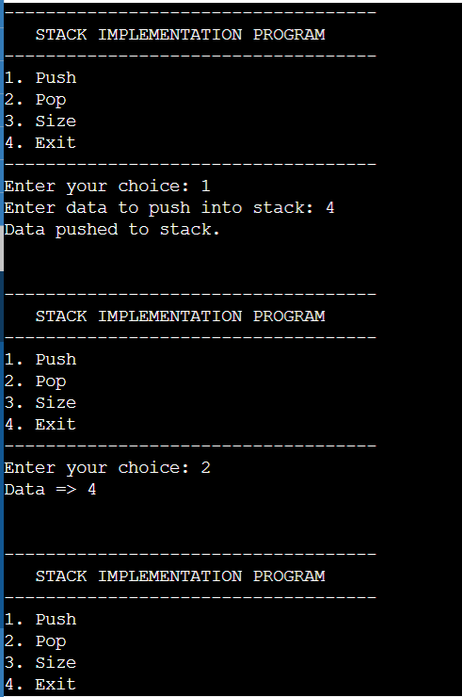

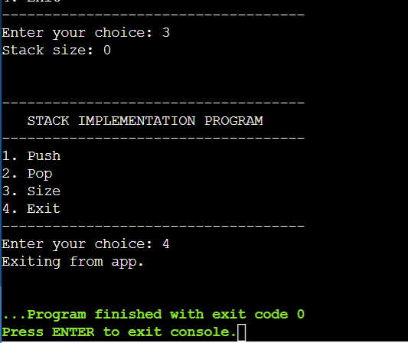

**Learning outcomes (What I have learnt):**

**Add item to the top of the stack.**

**• Remove an item from the top of the stack.**

**• Evaluation of expressions.**

**• Backtracking.**

**• Runtime memory management.**

**Evaluation Grid (To be created as per the SOP and Assessment guidelines by the faculty):**

|  |  |  |  |
| --- | --- | --- | --- |
| Sr. No. | Parameters | Marks Obtained | Maximum Marks |
| 1. |  |  |  |
| 2. |  |  |  |
| 3. |  |  |  |
|  |  |  |  |